Microsoft System Center Operations Manager Management Pack Guide for ARCserve Backup

Introducing Microsoft System Center Operations Manager Management Pack for ARCserve Backup

Microsoft System Center Operations Manager Management Pack for ARCserve Backup lets you monitor and manage ARCserve alerts using Microsoft System Center Operations Manager (SCOM). By detecting and alerting you on critical conditions, this Management Pack helps prevent possible service outages.

This document discusses how you can deploy and configure the SCOM Management Pack for ARCserve into your existing SCOM environment. When you import the SCOM Management Pack for ARCserve and integrate ARCserve and SCOM; SCOM receives the ARCserve Backup alerts that was configured in CA ARCserve Backup. As a result, SCOM can be used for the centralized management of ARCserve Backup alerts.

Integrating CA ARCserve Backup and SCOM

This chapter describes how you can integrate ARCserve Backup and SCOM to receive ARCserve Backup alerts using SCOM.
Prerequisites for ARCserve Backup and SCOM integration:
The prerequisites include the following:
- SCOM must be installed where the Windows Event log alerts are received.
- CA ARCserve Backup Manager (Console) component needs to be installed on machine where SCOM is installed. This is to capture ARCserve alerts with proper description.
- SCOM Management Pack for ARCserve must be imported on the SCOM server. This management pack consists of “ARCserve Backup MP.xml” and “SCOMMP Guide for CA ARCserve Backup.docx”.

Importing the SCOM Management Pack for ARCserve Backup

Before you use SCOM to receive and display ARCserve alerts, you must first import the SCOM Management Pack for ARCserve Backup on the SCOM server.

The following procedures describe how to import SCOM Management Pack for ARCserve Backup on the SCOM server.

To import SCOM Management Pack on the SCOM server:

- Launch the SCOM Operations Console on the SCOM server.
- In the Operations Console, click the Administration button.
- Right-click the Management Packs node and then click Import Management Packs.

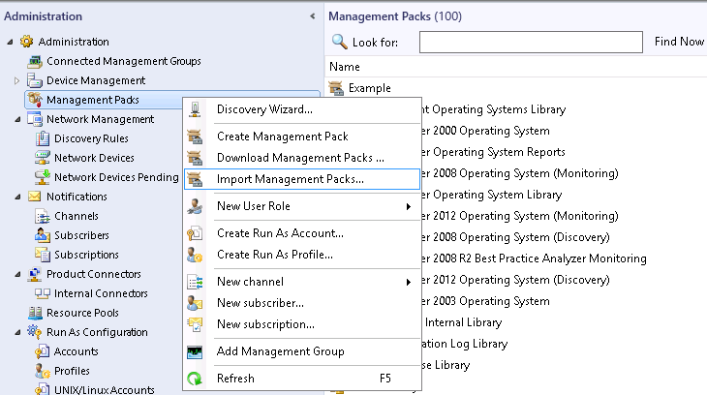

- From the Import Management Packs/Select Management Packs dialog, browse to the directory where the SCOM Management Pack is saved. Select ARCserve Backup MP.xml and click Open.
Note: ARCserve Backup MP.xml is shipped with the SCOM Management Pack for ARCserve Backup.

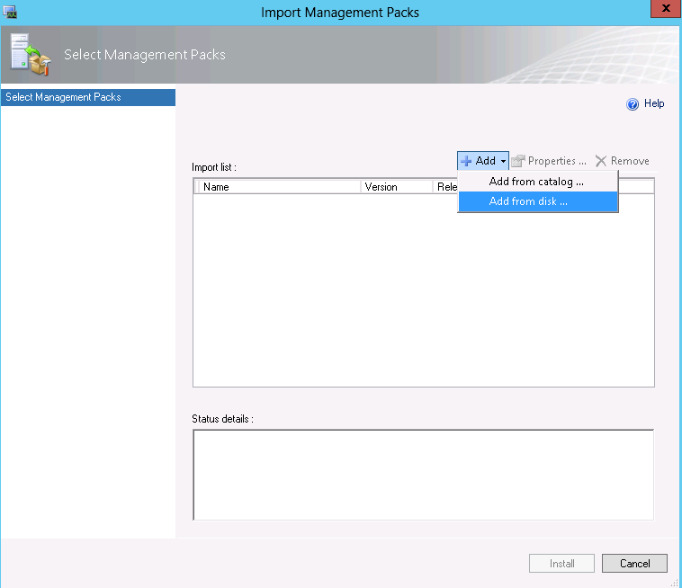

- Click Install to install the selected SCOM Management Pack.

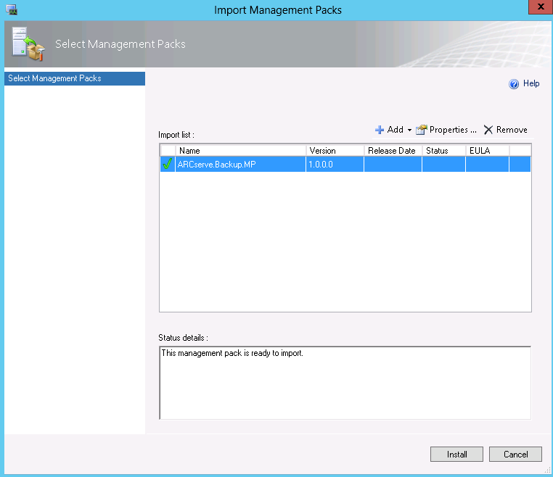
- After the import process is complete, click Close.
Note: The dialog box displays an icon next to each Management Pack indicating whether the import process completed or failed.

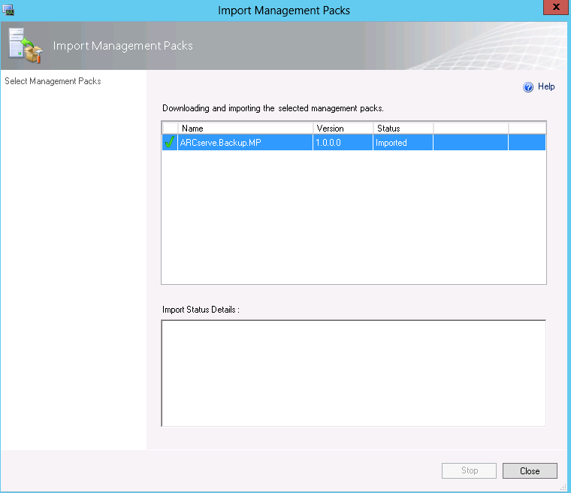

- You must restart the SCOM services after importing the Management Pack.

Viewing ARCserve Backup Alerts in SCOM

ARCserve Backup alerts can be viewed from the Monitoring pane in the Operations Console of SCOM on the SCOM server.

Use the following procedure to view ARCserve Backup alerts on the SCOM server.

To view ARCserve Backup alerts in SCOM 2007:

- Launch the SCOM Operations console on the SCOM server.
- Select Start > Programs > System Center Operations Manager >Operations Console.
- In the Operations Console, click Monitoring and select Active Alerts.

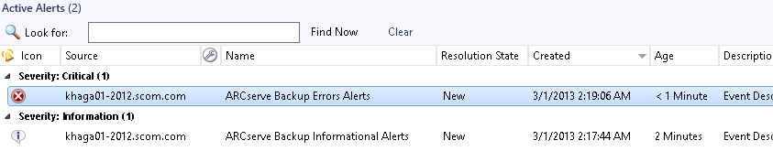

Creating custom rules in SCOM Management Pack for ARCserve Backup

Note: As a prerequisite, you must import the SCOM Management Pack for ARCserve Backup otherwise you cannot see the “ARCserve Backup MP” management pack in the list of management packs.
Use the following procedure to create your own custom rules for ARCserve Backup Alerts by creating an alert that generates NT-event-log-based rules for ARCserve alerts in the Operations Manager. The alerts generated by the rules will display in Alert Views.
Note: By default “ARCserve Backup MP” management pack has already defined three rules for capturing “Error Alerts”, “Warning Alerts” and “Informational Alerts” for ARCserve.
To create a custom alert that generates an NT-event-log-based rule for ARCserve in Operations Manager:

- Log on to the computer with an account that is a member of the Operations Manager Authors or Administrators role for the Operations Manager management group.
- In the Operations console, click Authoring .
- In the Navigation pane, expand Authoring, and then expand Management Pack Objects.
- Right-click Rules, and then click Create a new rule to start the Create Rule Wizard.
- Expand Alert Generating Rules, expand Event Based, and then click NT Event Log (Alert).
- Select “ARCserve Backp MP” as your Management pack from the list and Click Next.

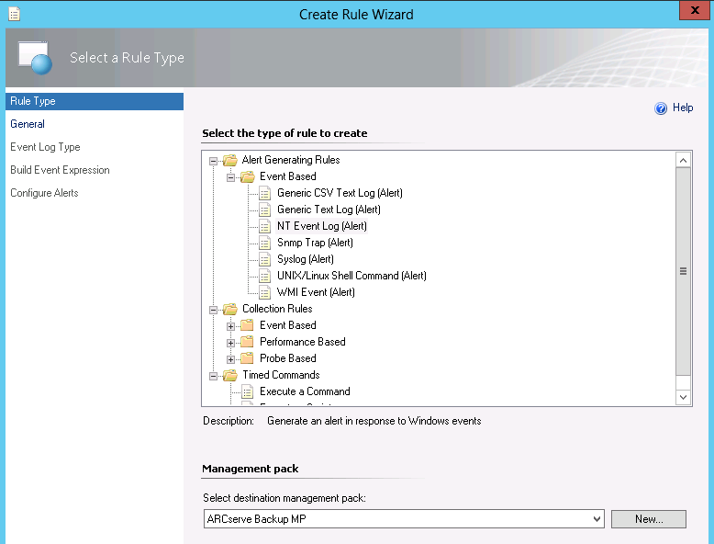

- From the Rule Name and Description screen, perform the following steps:
  - Specify the Rule name, for example ARCserve Errors Alerts.
  - (Optional) Type a Description for the rule.
  - Click Select, select the target as Windows Server, and then click OK.
  - Select Rule is enabled (selected by default). This option enables the rule you just created to take effect when the wizard completes.
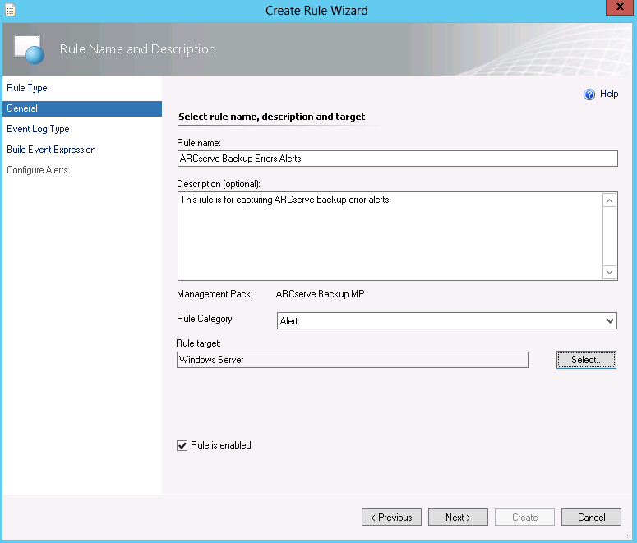
- From the Event Log Name screen, select Application from the Log Name drop-down to specify where to read the events from.
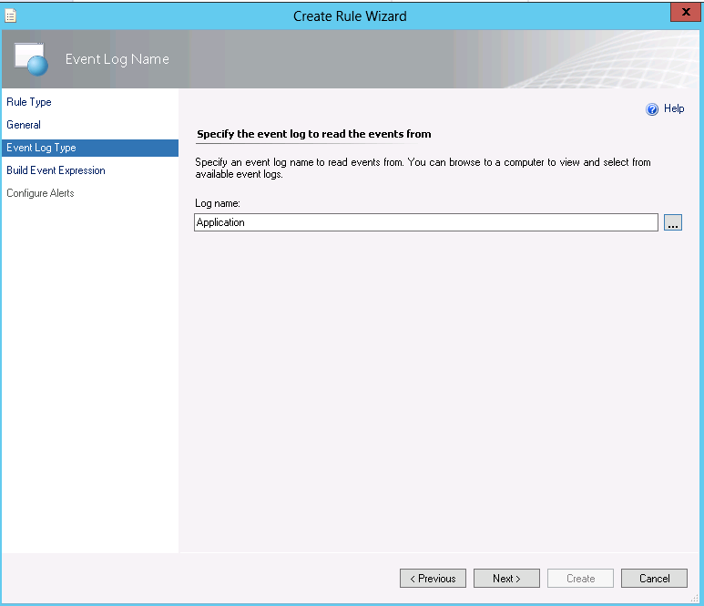
- From the Build Event Expression screen, build the query where the rule is used to generate alerts, for example:
  - Set the Event ID equal to “1” as the Windows Event ID of the ARCserve alerts is “1”.
  - Set the Event Source to a specific source of the events.
  - Click Next.
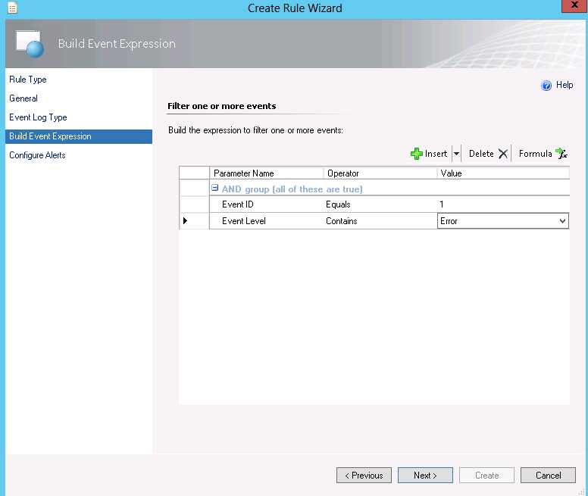
- From the Configure Alerts screen, set the properties of the alert.
  - Specify the name for the alert. For example, ARCserve Backup Errors Alerts.
  - (Optional) Specify the Description for the alert or click the ellipsis to select the Target and Data variables to include in the description, such as Event source, Event level, Event Description.
  - Select the Priority of the alert.
  - Select the Severity of the alert.
  - Click Create.
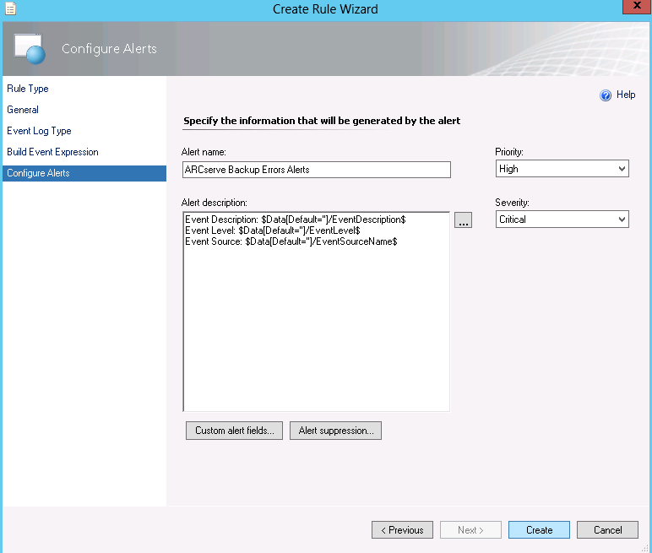
- The following steps are required to receive NT-event-log based alerts from remote ARCserve Backup machines.
  - Export the “ARCserve Backup MP” management pack to the local machine. The output is ARCserve Backup MP.xml file.
  - Update ARCserve Backup MP.xml to include “<AllowProxying>true</AllowProxying>” xml tag under each Rule->DataSources if it is missing.
Note: AllowProxying tag should be created for each custom rule that you are creating. There will be one Rule entry in xml for every custom rule that you create in the operations console.

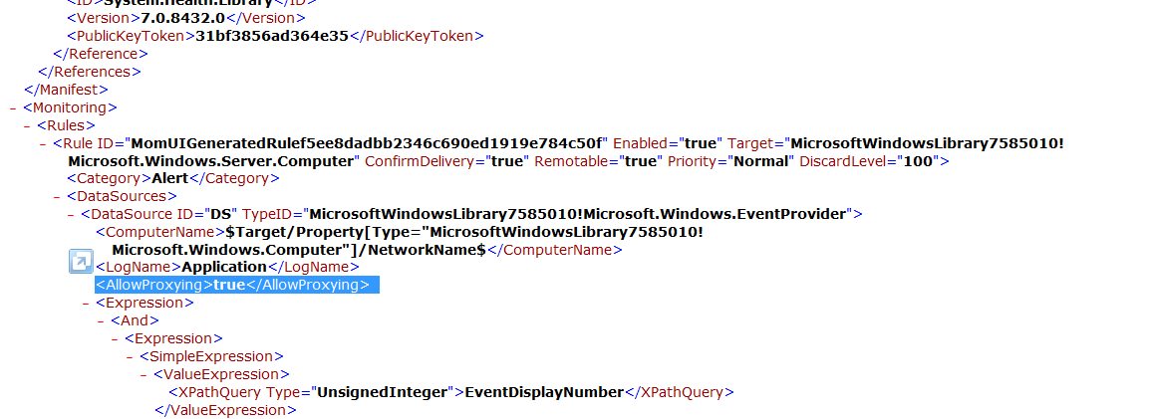
  - Delete the existing “ARCserve Backup MP” management pack from the list of management packs .

  - Import the updated “ARCserve Backup MP” management pack to the SCOM server. See the “Importing the SCOM Management Pack for ARCserve Backup” section for details.

Configuring CA ARCserve Backup

You must configure CA ARCserve Backup to send alerts to the desired SCOM Server. A SCOM Administrator can monitor and manage all ARCserve Backup alerts that are configured in ARCserve and then sent to the SCOM server as NT Event Log alerts.

Job Level Alerts

You can configure Job level alerts in the Alert tab from the Global Options dialog. These can be different for every job.

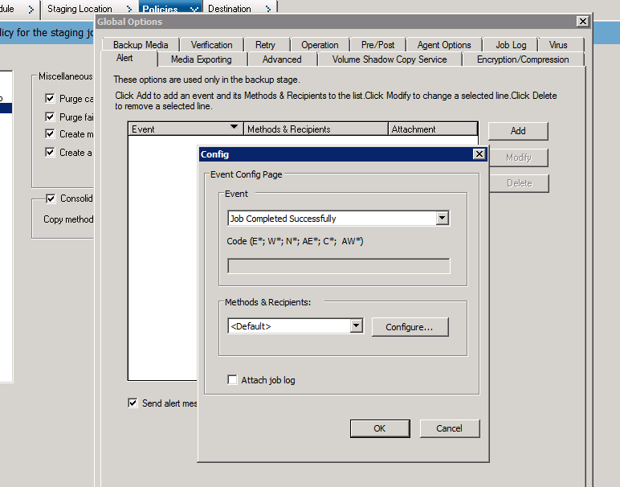

Server Admin Alerts

You can configure alerts across jobs in the Server Admin as displayed in the following screen. Configure specific strings that can be matched against every event generated.

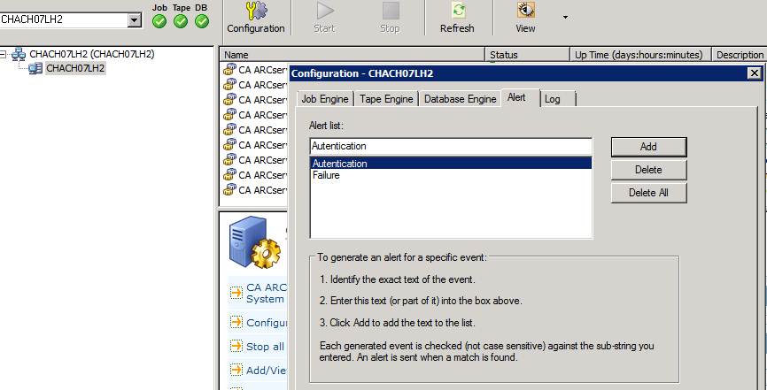

Alert Manager Configuration

You must configure the Alert Manager to send alerts to SCOM from the CA ARCserve Backup Primary server. You must configure the name of the SCOM server as the receiver of the Windows Event log as displayed in the following screen.

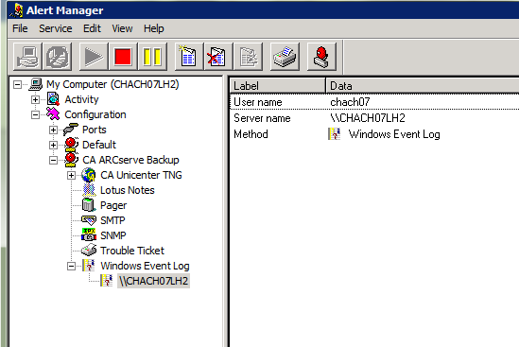

CA ARCserve Backup support for SCOM

This configuration will apply to existing and future releases of CA ARCserve Backup.

